Network Keyboard

Quick Operation Guide

Preventive and Cautionary Tips
Before connecting and operating your keyboard, please be advised of the following tips:
- Ensure unit is placed in a well-ventilated, dust-free environment.
- Keep all liquids away from the keyboard.
- Please check the power supply to avoid the damage caused by voltage mismatch.
- Please make sure the keyboard work in the allowed range of temperature and humidity.
- Please keep the device horizontal and avoid the installation under severe vibration environment.
- The dust board will cause a short circuit after damping; Please use the brush to dedust regularly for the board, connector, chassis fan, etc.
- Improper use or replacement of the battery may result in hazard of explosion. Replace with the same or equivalent type only. Dispose of used batteries according to the instructions provided by the battery manufacturer.
Table of Contents
Chapter 1 Introduction 3
1.1 Overview 3
1.2 Appearance 3
Chapter 2 Quick Configuration Guide 5
Chapter 3 Operation Guide 8
3.1 Local Live View 8
3.2 Display of Decoded Video on Monitor 9
3.2.1 Setting Multi-division Display 9
3.2.2 Displaying Decoded Video on Monitor 10
3.3 PTZ Control 10
3.4 Playback 11
3.4.1 Local Playback 11
3.4.2 Playback of Decoded Video on Monitor 13

Chapter 1 Introduction

1.1 Overview
HKB-1100KI Network Keyboard can be used to control the camera/speed dome, display of decoded video on TV wall, control of matrix, as well as support 1 channel of video view at up to 1080P resolution. Designed with touch screen, it is easy to operate and configure settings.

1.2 Appearance
Front View:
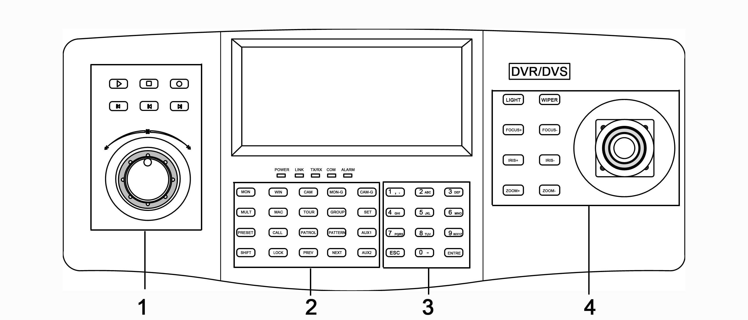
Description of panel:
Serial No. | Description | Serial No. | Description
1 | Record playback | 2 | Functional buttons
3 | Numeric buttons | 4 | PTZ control area

Interface Description:
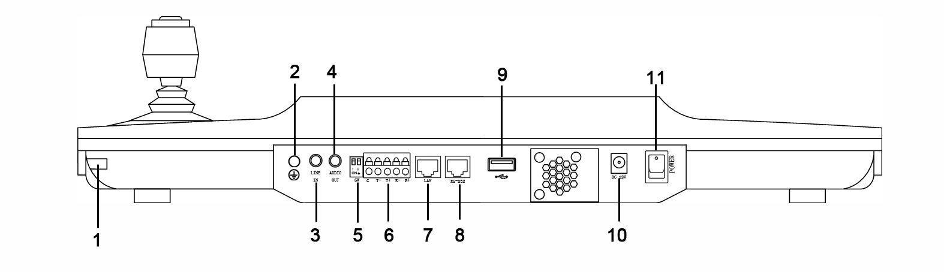

Serial No. | Description | Serial No. | Description
1 | Touch pen | 2 | GND
3 | Line In | 4 | Audio Out
5 | Reserved | 6 | RS-485 Interface
7 | LAN | 8 | RS-232 Interface
9 | USB Interface | 10 | 12V DC Power Supply
11 | Power On/Off

Chapter 2 Quick Configuration Guide
Steps:
- When the keyboard has started up, it enters the following interface:
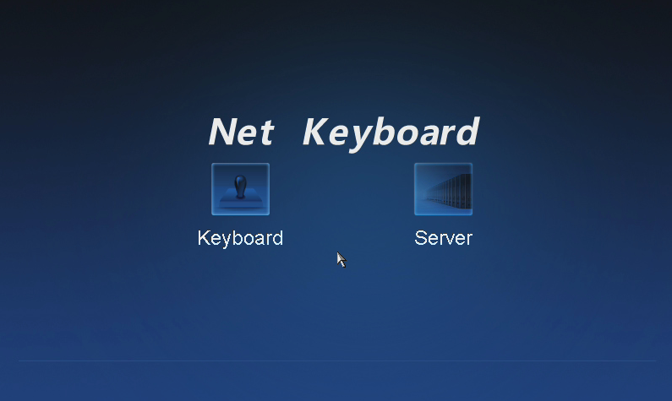
- For basic keyboard operation, select the Keyboard icon to continue and enter the login interface.
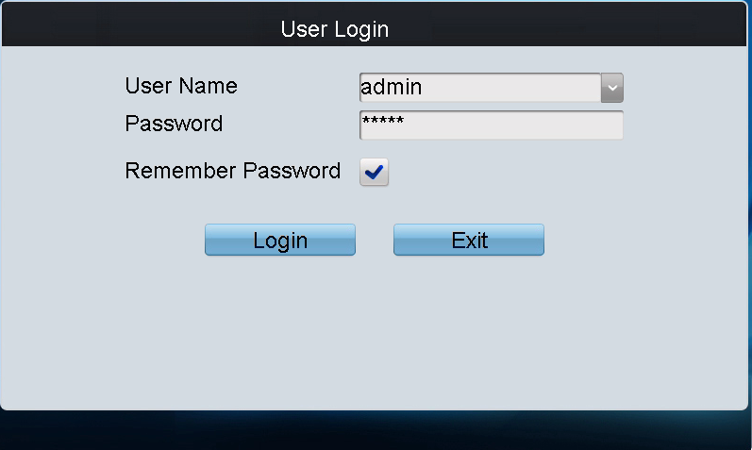
- Select admin on the login interface and then input the admin password (default: 12345) to enter the admin interface of keyboard operation.
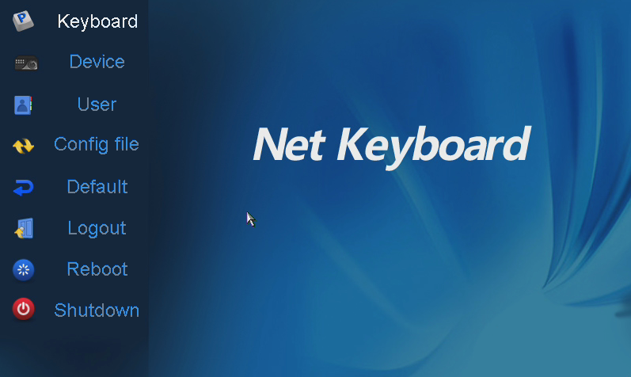
- Click Keyboard > Network to enter the Network Settings interface.
Configure the network settings of the keyboard, including the Port, IP address, Subnet Mask, Default Gateway, Primary DNS and Secondary DNS. Click Apply to save the settings.

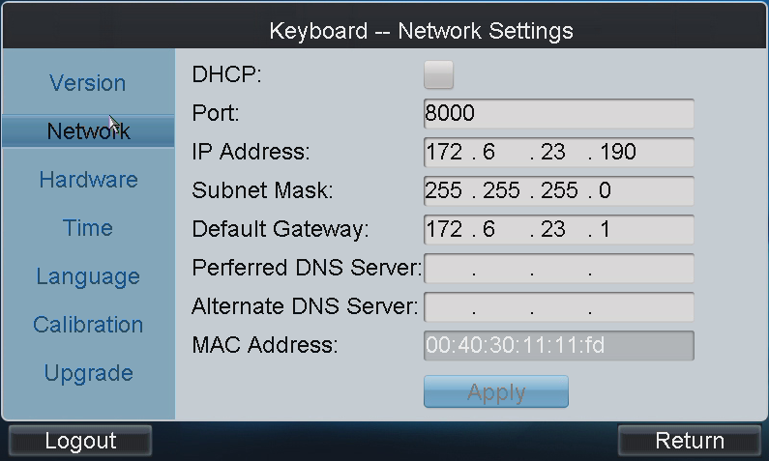
- Click Return to back to the main interface.
- Click Device on the admin main interface to enter the device management menu.
- Click Add Device to enter the Device-Add Device interface. Input the device name, device IP/domain name, port, user name and password, and then click Add to add the device.
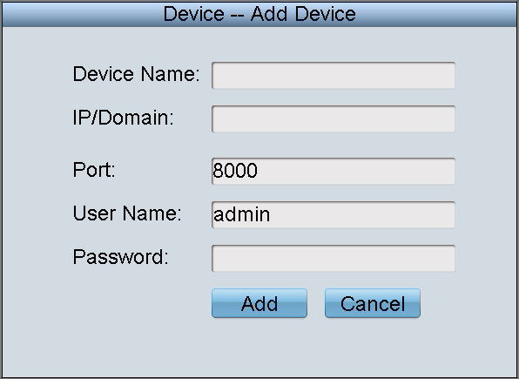
- Return to the Device-Device List interface, and the successfully added device is shown on the list. Click Return to back to the main interface.
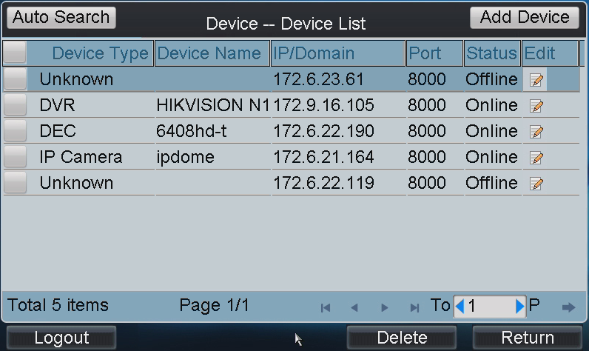
- Click User on the main interface to enter the User-User List interface.
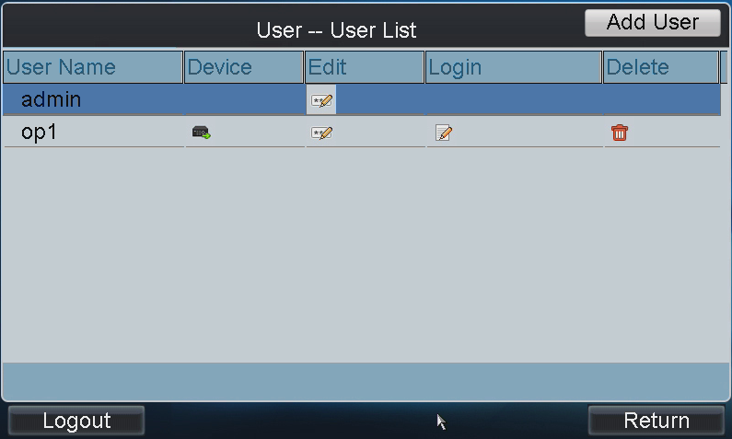
- In the User List interface, click Add User to enter the Add User interface. Input the user name, password and verify the password. Finally, click Add to finish the adding of user.
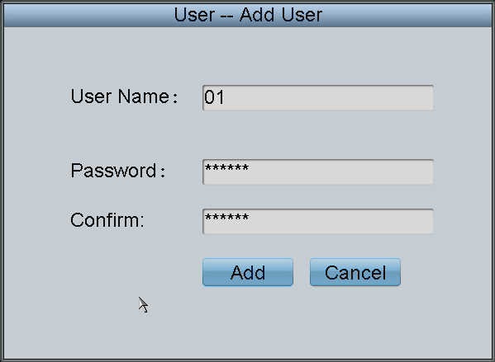
- Return to the User List interface, and click of the selected user to enter the User-Device interface.
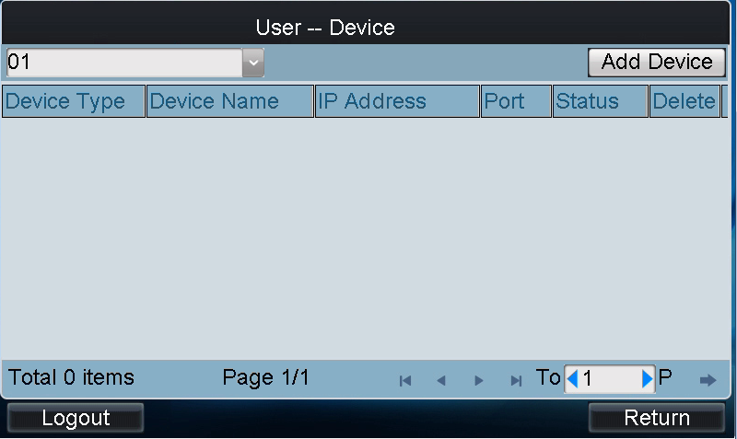
- Click Add Device to enter the User-Add Device interface. Select the device by clicking the checkbox, and click Add to add the device for the current user.
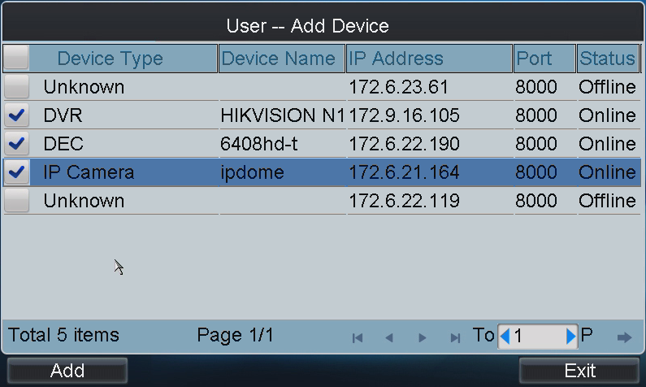
- The added device (s) for the current user can be displayed on the User List interface.
- You can directly click the (Login) icon of a user to switch its operating interface.
Or you can click Logout on the admin main interface, the message box “Logout Now?” will pop up. Click Yes to confirm the logout, or No to cancel the operation.
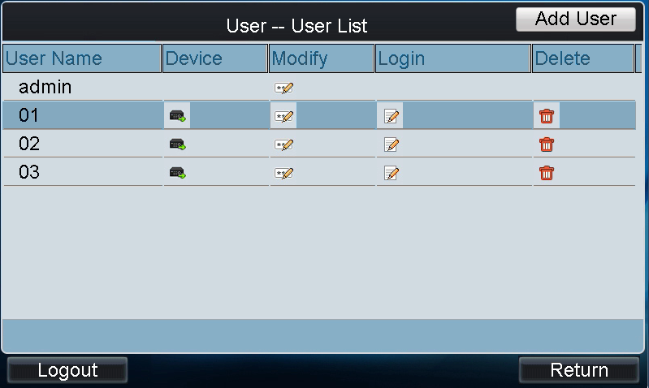

Chapter 3 Operation Guide
Note: The keyboard operation must be done by the operator user account.
Steps:
- On the User Login interface, select the user name (operator) and enter password.
- If needed, check the checkbox of Remember Password to save the login password for future use.
- Click Login to enter the operator main interface.
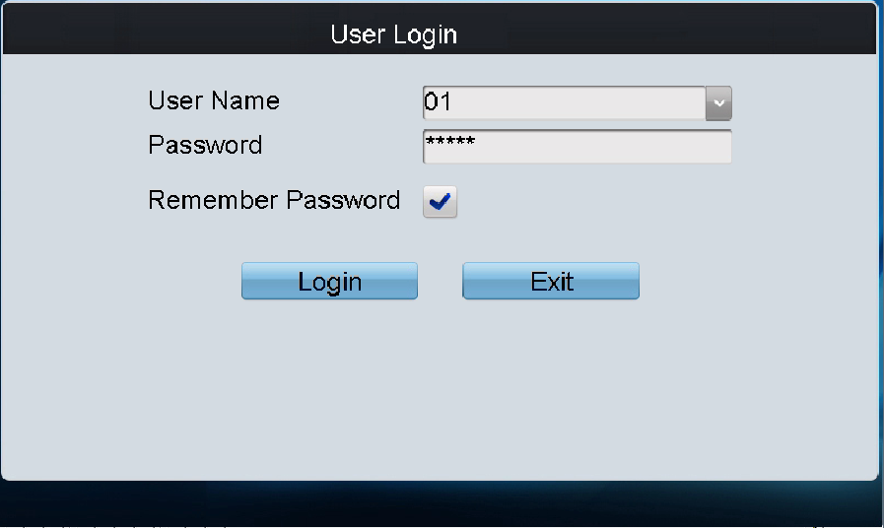
- Enter the main interface.
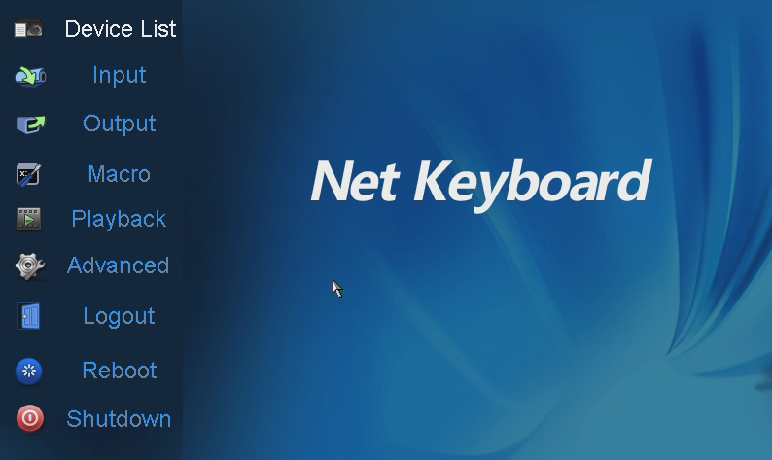

3.1 Local Live View
The local live view refers to display the video signal from the input channel through the network keyboard. Currently, only the 1-window display mode for 1 decoding channel is supported. In the preview mode, you can operate other shortcut functions.
Steps:
- Press the 0+MON keys to enter local live view.
- Press the Num + CAM keys to select the camera input for display on the screen.
Note: In the local operation status, it is unallowable to operate the window (WIN), camera group (CAM-G), multi-division display (MULT) and camera tour (TOUR) functions.
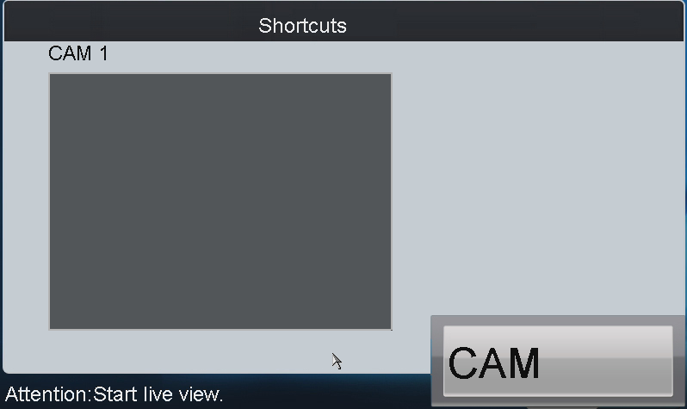
- Press the ESC key on the keyboard to enter full-screen preview mode.
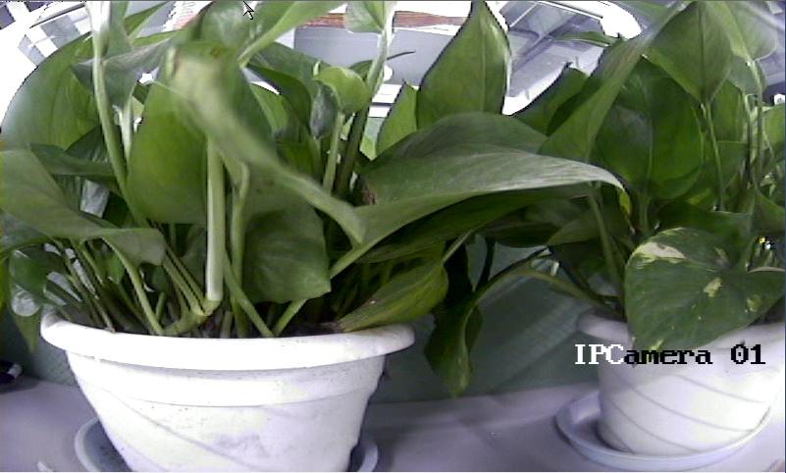
Notes:
- Up to 1080P resolution is supported for local live view.
- You can press the 0+CAM keys to stop the dynamic decoding of the current window.

3.2 Display of Decoded Video on Monitor

3.2.1 Setting Multi-division Display
You can select different multi-division display modes for the selected output channel. Currently, 1/4/9/16-division display modes are configurable.
Steps:
- Press the Num + MON keys to select the monitor.
- Press the Num + MULT keys to select the multi-division display mode for the output channel.
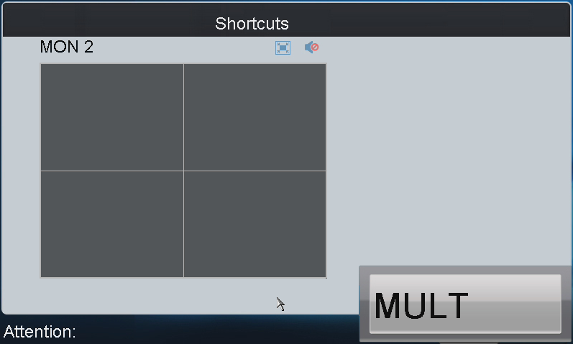

Notes:
- In the local live view mode when you input 0+MON keys, the multi-division display mode is not supported.
- Corresponding error message will appear on the screen when user performs wrong operation. E.g., when the multi-division number entered is not supported by the current output monitor, the message ”wrong operation” will appear.

3.2.2 Displaying Decoded Video on Monitor
The selected input signal can be outputted and displayed by the decoding channel on the monitor. Currently, the supported decoding resolution includes: QCIF, CIF, DCIF, 2CIF, 4CIF, 720p, 1080p, VGA, UXGA, etc. The output interface can be selected to BNC/VGA/HDMI/DVI.
Steps:
- Press the Num + MON keys to select the monitor.
- Press the Num + WIN keys to select the display window on the monitor.
You can also directly touch the screen to select the display window.
- Press the Num + CAM keys to select the input camera.
Example:
You can input the “1+MON, 2+WIN, 3+CAM” keys to decode the video signal from camera 3 and display it on window 2 of monitor 1.
When you press the 0+CAM keys, it will stop the dynamic decoding of the current window. If no display window is selected, the decoding of the 1st window will be stopped by default.
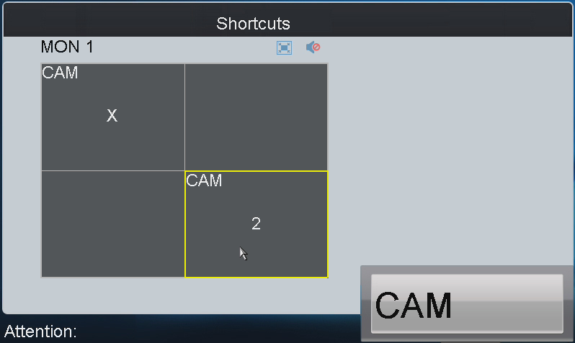
Description of icons:
Switch to full screen of sub screen | Restore | Audio off | Audio on
Note: Corresponding error message will appear on the screen when you perform wrong operation.

3.3 PTZ Control
If the camera connected to the keyboard supports PTZ function, you are allowed to operate the LIGHT/FOCUS/IRIS/ZOOM/WIPER buttons and joystick to realize PTZ control in the live view mode of the decoded video.
Two operation methods can be used to realize PTZ control:
Method 1:
- Press the Num + MON keys to select the monitor.
- Press the Num + WIN keys to select the display window.
Note: When the current window is in cycle view mode, the keyboard will be unable to automatically connect with the camera and now it is invalid to operate the joystick.

Method 2:
- Press the Num + CAM keys to directly select the camera.
- When the camera connected to the keyboard supports PTZ function, operate the joystick and LIGHT/WIPER/FOCUS±/IRIS±/ZOOM buttons to realize PTZ control.
When the purpose of AUX1/AUX2 key has been set to PTZ Speed, you can use the key to adjust the PTZ control speed.

3.4 Playback

3.4.1 Local Playback
The video files stored in the encoding device can be played back through the related decoder. Three playback modes are available: playback by USB file, playback by time and playback by file.
Click Playback on the main interface to enter the Local Playback interface.
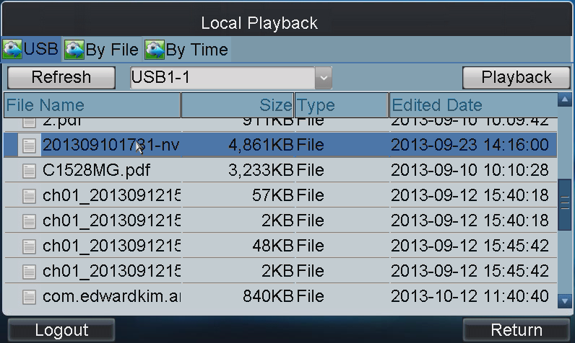

Playback by USB File
Steps:
- Connect your USB disk to the keyboard.
- Click the USB tab on the Local Playback interface to enter the Playback by Local File interface.
- Select the video file from the USB disk for playback.
- Click Playback to play the selected video file.
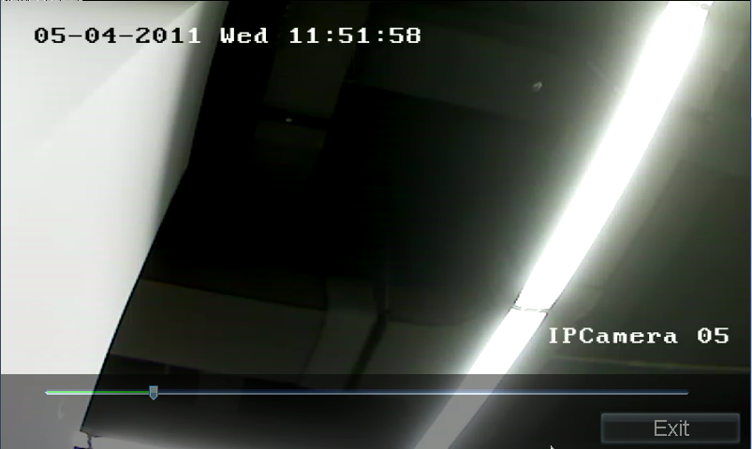

Playback by File
Steps:
- Click the By File tab on the Local Playback interface to enter the Playback by File interface.
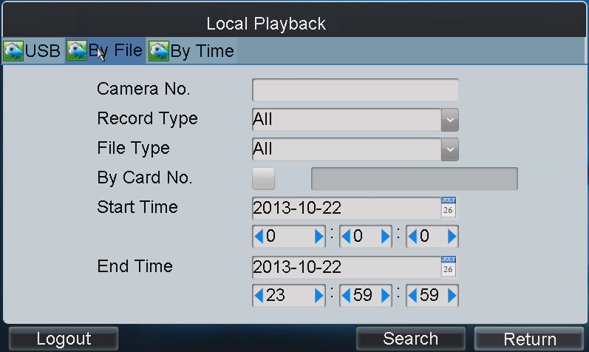
- Input the Camera No. for playback.
If the encoding device is ATM DVR, you can input the Card No.
- Select the record type and file type.
- Set the start time and end time of the video files for playback.
- Click Search to search the matched video files.
- The searching results can be viewed on the Playback File List interface.
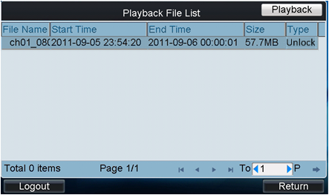
- Select the file for playback from the list and click Playback to play back the video file.

Playback by Time
- Click the By Time tab on the Local Playback interface to enter the Playback by Time interface.
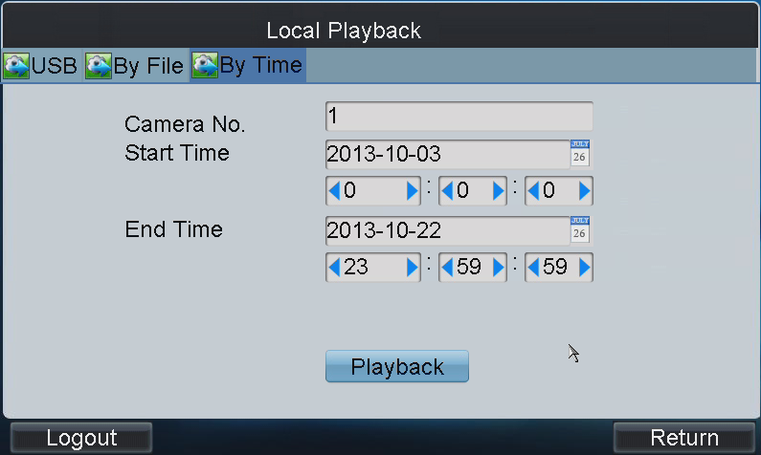
- Input the Camera No. for playback.
- Set the start time and end time of the video files for playback.
- Click Playback to play back the recoded video.

3.4.2 Playback of Decoded Video on Monitor
Click Output on the main interface to enter the Output Settings interface. The list has displayed all output channels added to the current login operator user.
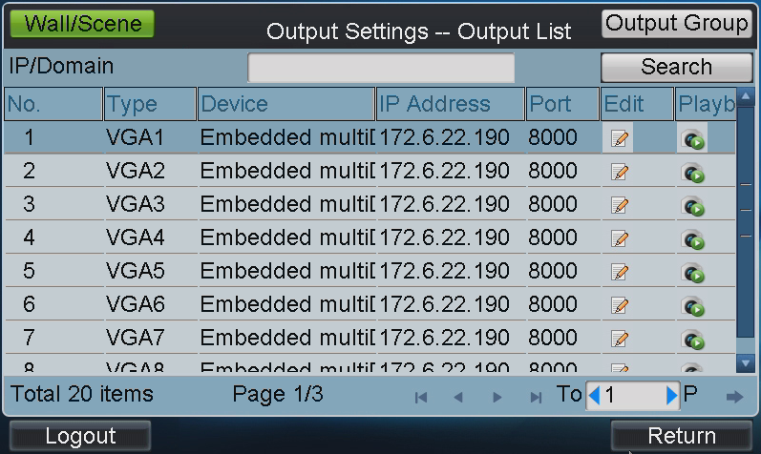
Select an output channel from the output list and click the 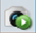 icon to enter the Playback interface.
Note: Before operating the playback, you must configure the output settings first.
You can play back the decoded video on monitor by file or by time.
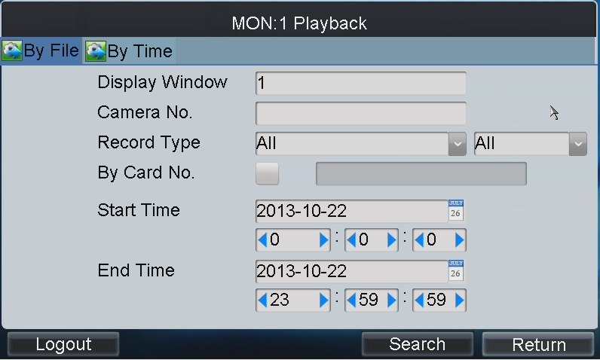
Please refer to section Playback by File and section Playback by Time to operating steps.

